@and-Architecture PLZ HALP

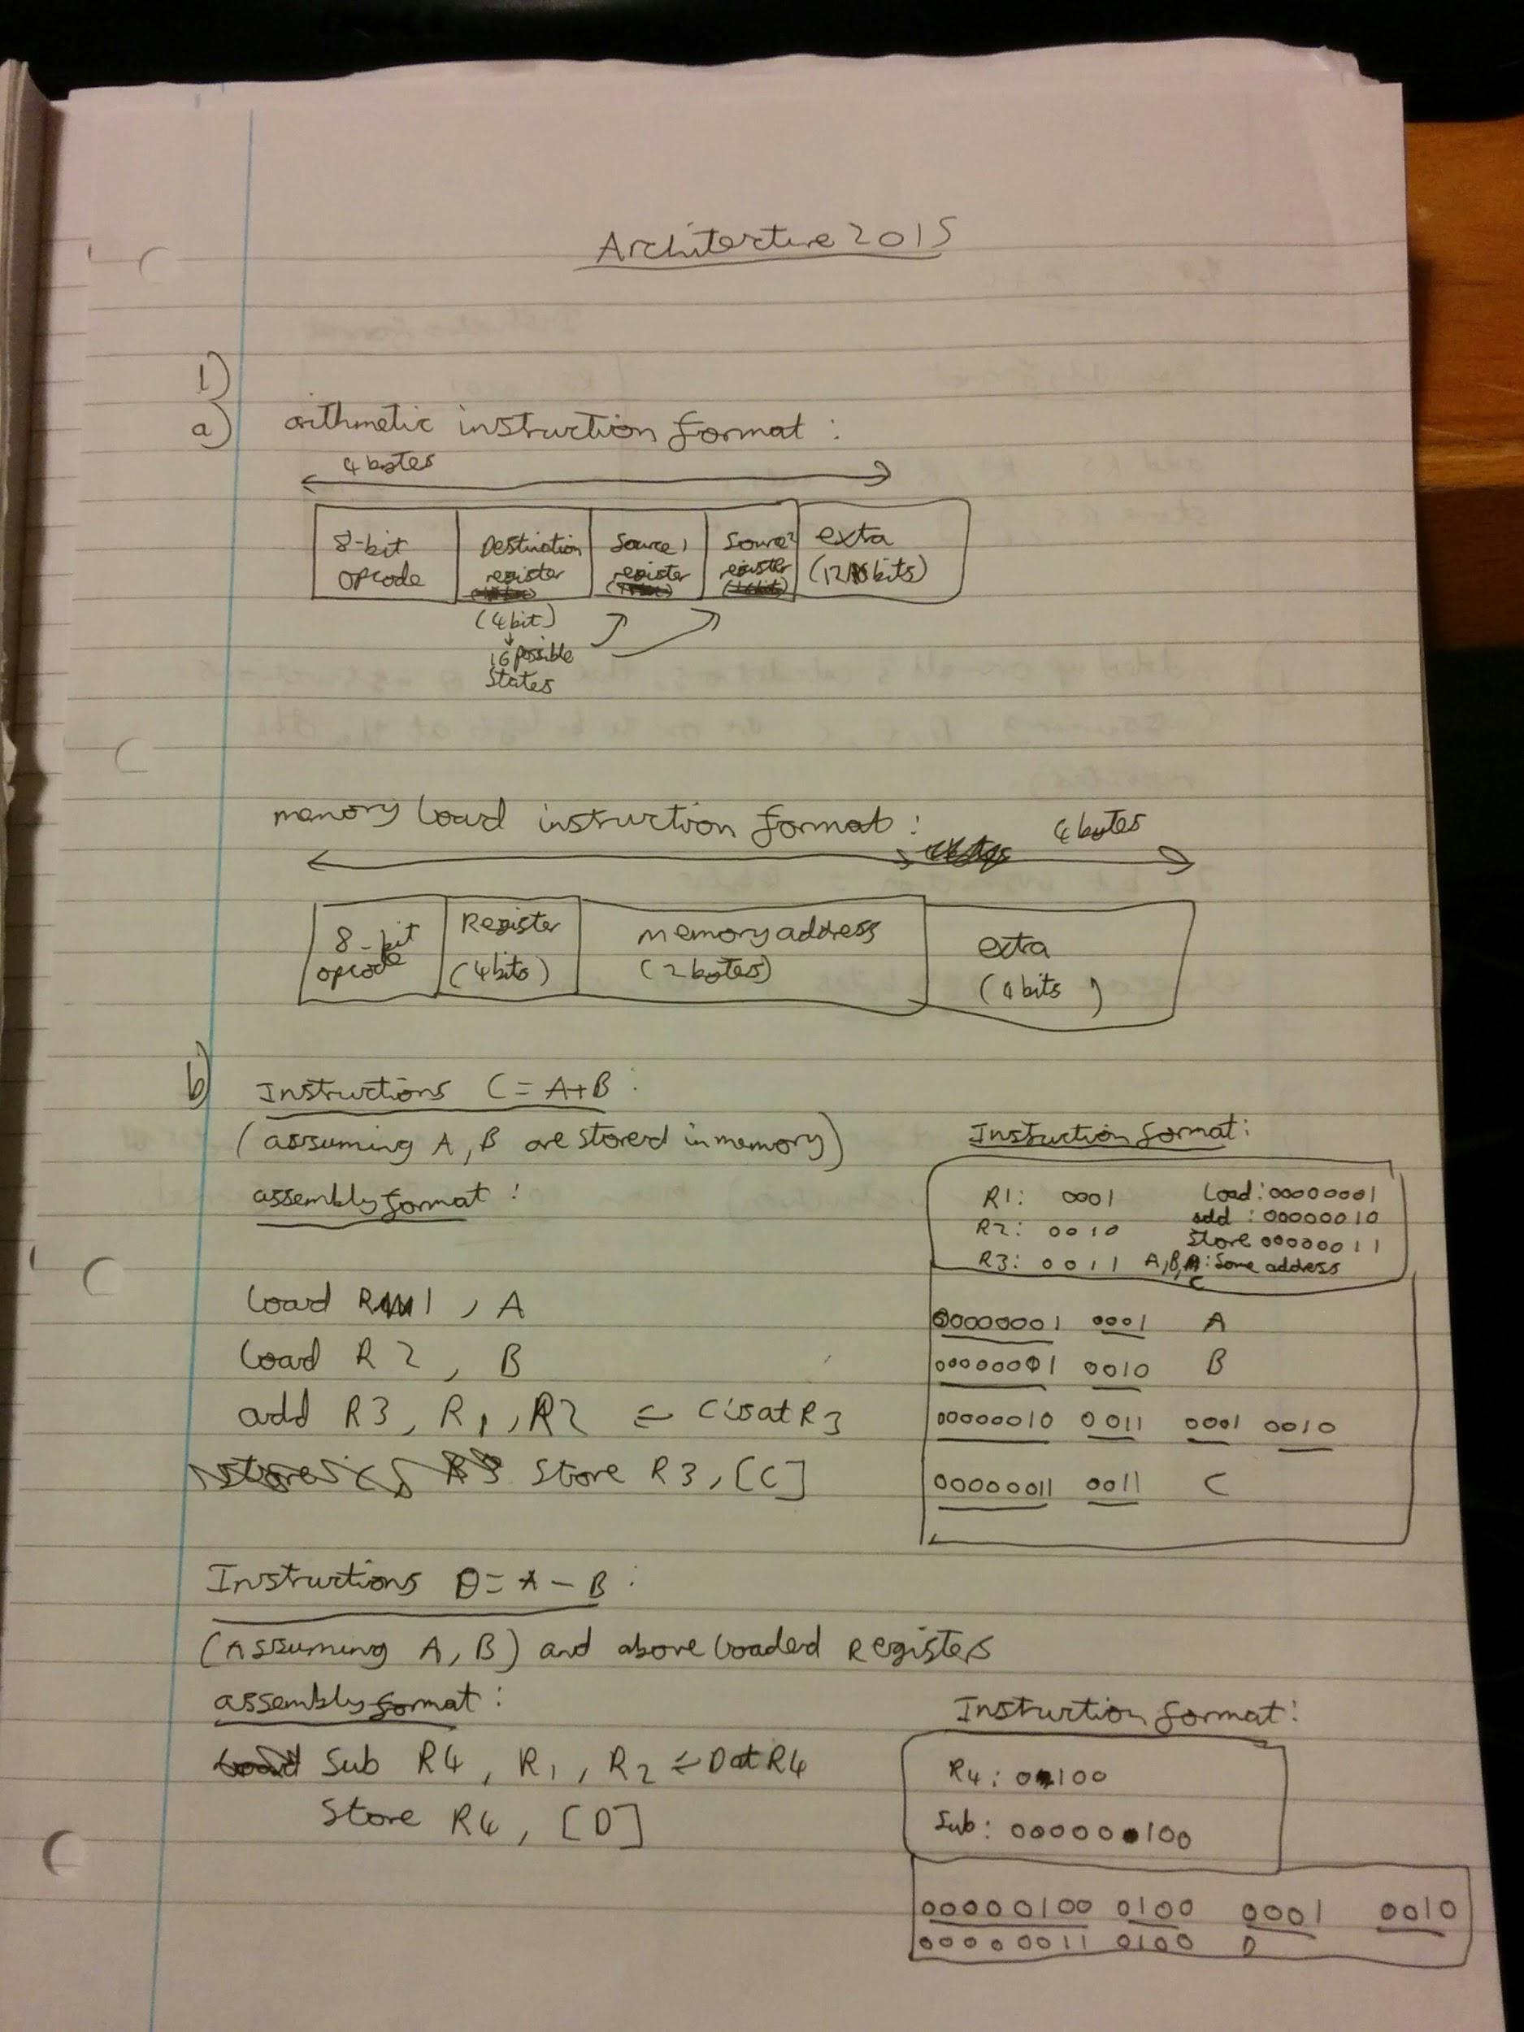

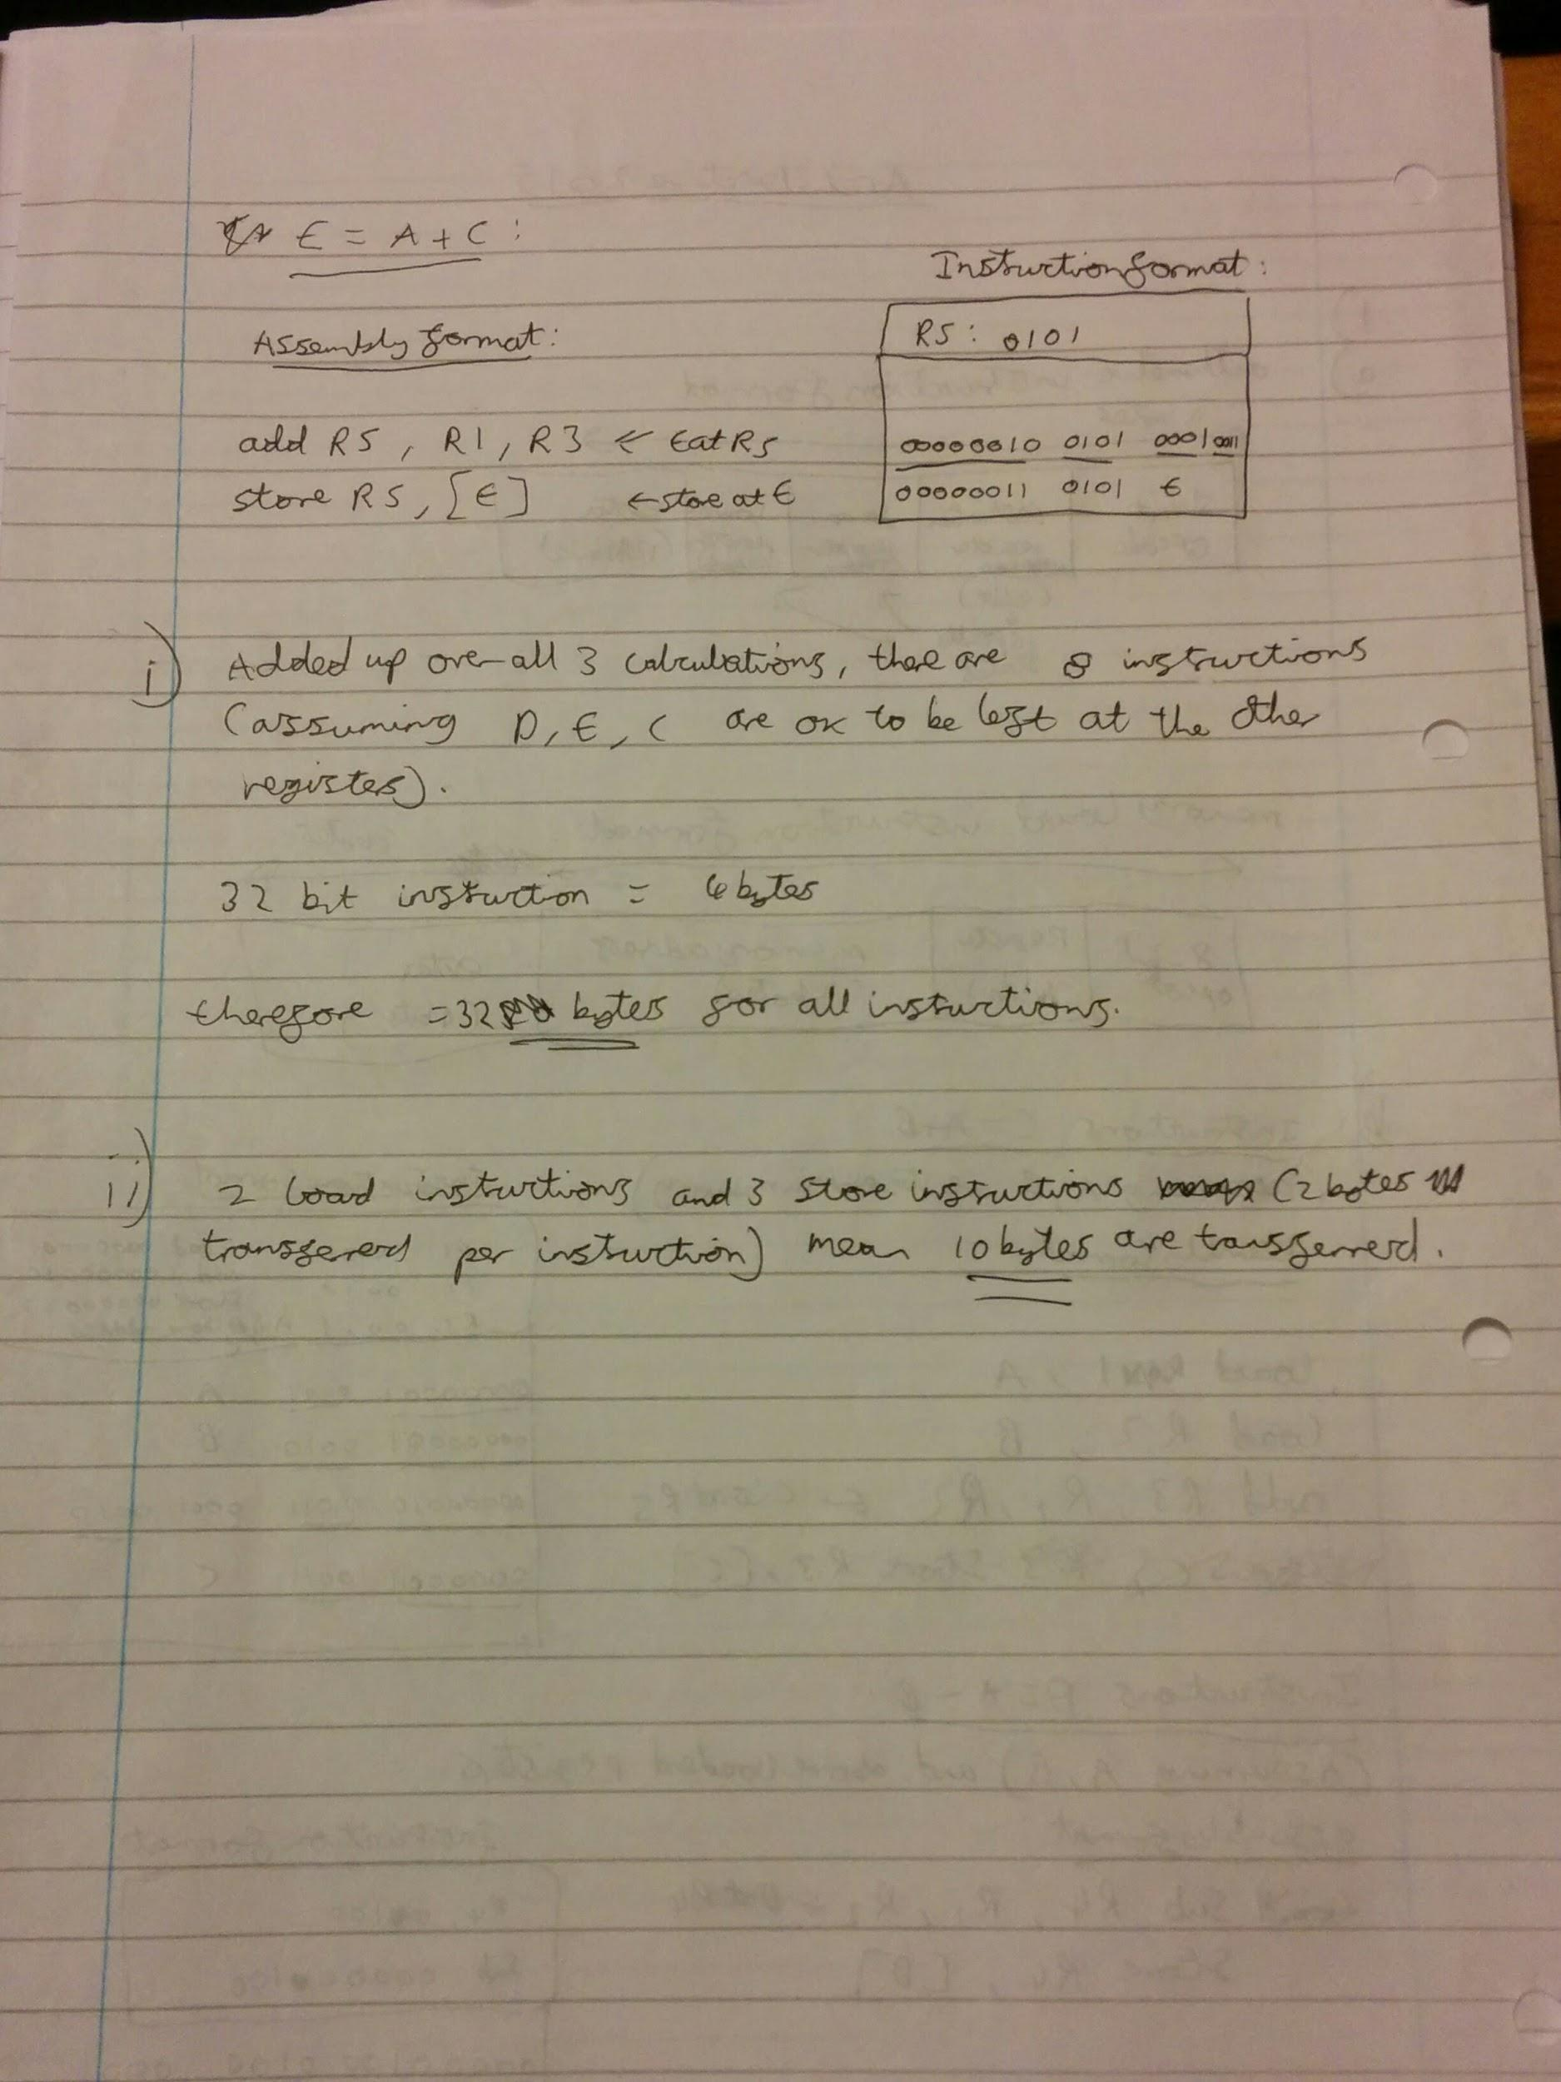h

8

2. (a) - Base + index register: Mem[ R[Eb] + R[Ei] ], used to access array elements when start of array is dynamically determined

* Relative based index: Mem[ R[Eb] + R[Ei] + D], access arrays of an object or within an object, and arrays on the stack
* General form: Mem[ R[Eb] + R[Ei] * s + D ], efficient access to array elements within objects and on the stack (when size of elements = 1, 2, 4 or 8 bytes)

(b) CC800000 = 1100_1100_1000_0000_0000_0000_0000_00002

= - 67 108 864

CC880000 = 1100_1100_1000_1000_0000_0000_0000_00002

= - 71 303 168

(c) -525.25 = 1100_0100_0000_0011_0101_0000_0000_00002

= C4035000

(No rounding so accurate?)

d) <https://godbolt.org/g/jmKzDx>